SAVVY LEADERSHIP STRATEGIES FOR WOMEN
AWAKEN THE LEADER IN YOU BY CARLA WELLINGTON BORN TO LEAD, 2011
(3) THE PURPOSE OF VISION
“It's a terrible thing to see and have no vision” - Helen Keller, American author, political activist and lecturer
(5-7) WHY IS VISION SO IMPORTANT?
"Where there is no vision, the people perish." -Proverbs 29:18, The Holy Bible, King James Version
CLARIFYING YOUR VISION
- Taking inventory of yourself
- Writing your vision statement
(8) “Vision without action is merely a dream. Action without vision just passes the time. Vision with action can change the world.” -Joel A. Barker, American scholar and futurist
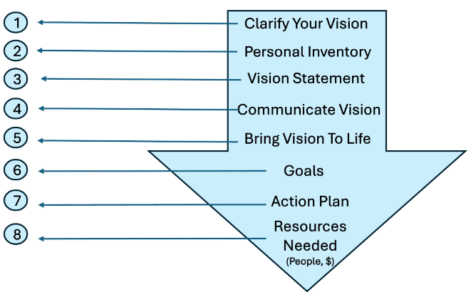
(9)

(10) The two major categories of resources include people and finances. ”Learn to move toward your goals and desires, one step at a time-often just one baby step at a time-and learn to love the doing. When you multiply tiny pieces of time with small increments of daily effort, you too will find you can accomplish magnificent things. You [will] find you can change the world.”-Jaroldeen Asplund Edwards, American author
(13) What is the secret to being truly respected and followed as a female leader? A savvy leader is strong, confident and grounded. She works well with and inspires others, is strategic, results-focused and manages adversity with grace. Savvy leaders are not born. They are made through taking risks, learning from mistakes, consistently developing themselves and getting up one more time than they fall down.
(14) FOUR STEPS TO BECOMING A SAVVY LEADER
1. Believe in Yourself
2. Determine Your Strengths, Manage Your Weaknesses
3. Come from the Right Place
4. Continue to Grow and Develop
(16) "Find something you're passionate about and keep tremendously interested in it."-Julia Child, American chef and author
(17) Take time to determine your own individual top strengths:
Responsible Influential Proactive Positive
Visionary Creative Decisive Leadership
Articulate Driven Innovative Thorough
Judgment Strategic Intelligent Collaborative

(23) THE LEADERSHIP MINDSET Transform Your Life from the Inside Out By Jane Morrison
(24) "No one can make you feel inferior without your consent." -Eleanor Roosevelt, former first lady of the United States
(26-32) 1. Envision a Positive Outcome for Every Situation
2. See Leadership Opportunities All Around YOU
3. Eliminate the Negative, Increase the Positive Influences. "Keep away from people who belittle your ambitions. Small people always do that, but the really great make you feel that you, too, can become great.-Mark Twain, American author and humorist
4. Leadership Mindset Is a Way of Life
5. Treat Yourself and Others with Kindness
6. Take Risks, Strive to Learn Something Every Day
7. Pay It Forward
IMAGINE THE POSSIBILITIES!
(35) "We're here for a reason. I believe a bit of the reason is to throw little torches out to lead people through the dark.?" -Whoopi Goldberg, American actress
(36-40) 1. Do Your Work Graciously
2. Do What You Say You Are Going TO DO
3. Put Yourself in Other People's Shoes. "Self-awareness: An awareness of one's own personality or individuality"
(45) LEADERSHIP IS A GROWTH PROCESS BY LANELL SILVERSTEIN
(46-48) - Leaders Never Stop Learning
- Leaders Surround Themselves with Other Leaders
- Leaders Believe They Can Achieve. "Go confidently in the direction of your dreams. Act as though it were impossible to fail." -Dorothea Brandt, American author
(50-54) Leaders Accept Responsibility and Take Action
- Leaders Lead by Example. "Being powerful is like being a lady. If you have to tell people you are, you aren't" -Margaret Thatcher, British, former prime minister
- Leaders Are Resilient
- Understand the challenge
- Manage stress
- Monitor your impact on others
"The challenge of leadership is to be strong, but not rude; be kind, but not weak; be bold, but not a bully; be thoughtful, but not lazy; be humble, but not timid; be proud, but not arrogant; have humor, but without folly." -Jim Rohn,
Start Cultivating Your Leadership Skills
(57) REINVENTION WITH INTENTION BY KAREN BÁEZ
(59-60) The Fundamentals of Reinvention with Intention
- Vision
- Commitment
- Declaration
"We are limited, not by our abilities, but by our vision? -Author Unknown
(65) Reinvention with Intention Starts Now!
(67-75) LEADERSHIP REQUIRES VITALITY BY CAROLYN PHILLIPS, ACE
Good Nutrition Creates Powerful Leaders:
- Eat and feel great
- Remember vitamins and minerals
- Avoid additives
- Sugar taps your immune system
- Drink, Drink, Drink
- Exercise and Good Lifestyle Choices Make Good Leaders
- Weight training benefits
- Cardiovascular benefits
- Stress busting benefits
- Caffeine
- Sleep
- Posture
- Breaks
- Breathe
- Take Action and Use Your Body to Be a Better Leader
(77-84) USING INTUITION AND INSIGHT TO BECOME A BETTER LEADER BY MARCI NEMHAUSER
Using Your Women's Intuition. "Nothing in life is to be feared. It is only to be understood." - Marie Curie, Polish-born French physicist and Nobel Prize winner
"TA DA!”
- Take in information using all your senses
- Assess what this information means
- Discern and decide what and how much of this information you will use
- Act on what you have determined to be an appropriate response to the information you have received.
GUTSY LEADERSHIP
- Paint the picture
- Visual Listeners
- Auditory Listeners
- Kinesthetic listeners
"A leader takes people where they want to go. A great leader takes people where they don't necessarily want to go but ought to be." Rosalynn Carter, former first lady of the United States
- Be a change agent
- Lead from behind
(88) SUCCESS APPEAL SHOW UP AS THE LEADER YOU ARE BY KAREN SOLOMON
CLOTHING AND STYLE
(91-92) CONFIDENCE. "A good leader inspires people to have confidence in the leader, a great leader inspires people to have confidence in themselves." -Eleanor Roosevelt, American, former first lady of the United States
CHARISMA. "Charisma is a sparkle in people that money can't buy. IPs an invisible energy with visible effects." - Marianne Williamson, American author, lecturer and activist
(94-95) Make and maintain good eye contact, and Communicate like a leader

SHOW UP AS THE LEADER YOU ARE
- Your clothing and style
- Your confidence
- Your charisma
(99-105) THE SAVVY WOMAN'S GUIDE TO A POLISHED IMAGE BY LAURA RUBELI
Your professional image says a lot about who you are inside. Within seconds of meeting someone, they can assess your education level, financial stability and confidence- all based on your appearance. Success depends on how you are perceived by others. "What a strange power there is in clothing." - Isaac Bashevis Singer, Jewish- American
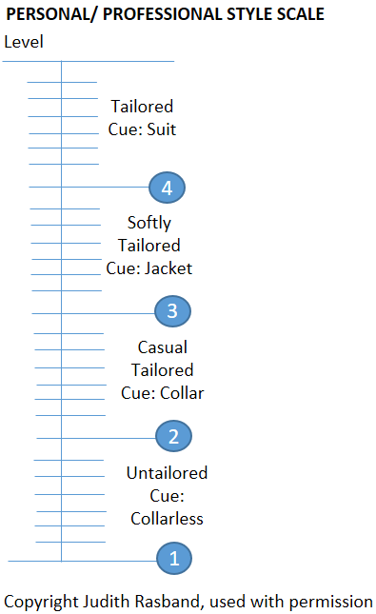
TAILORED LEVEL 4: This style of dress communicates authority, credibility, capability and responsibility.
Typical situations to wear tailored dress include:
- Leading a formal meeting or conference
- Making a formal presentation
- Formal cocktail networking
- Representing your company in public
SOFTLY TAILORED LEVEL 3: This style of dress communicates the traits accessibility, receptiveness and trust.
Typical situations to wear softly tailored dress include:
- Leading less formal to informal meetings or conferences
- Making a less formal presentation
- Informal networking
- Less formal meetings with clients or customers who wear relatively more casual clothes
CASUAL TAILORED LEVEL 2: This style of dress communicates the traits approachable, knowledgeable, cooperative and conscientious.
Typical situations to wear casual tailored dress include:
- Making a casual, preliminary presentation
- Relaxed office meetings
- Casual visits with customers known to wear very casual clothes
- Casual networking
UNTAILORED LEVEL 1: This casual look communicates the traits informal, hard-working, dependable, and relaxed.
Untailored clothes have relaxed shapes, curved lines and lighter colors.
DRESSING FOR YOUR BODY TYPE."Fashion is architecture, it is a matter of proportions." -Coco Chanel, French fashion designer
(108-109) Mere color, unspoiled by meaning, and unallied with definite form, can speak to the soul in a thousand different ways." - Oscar Wilde, Irish poet and dramatist
- Black: Black is considered a color of power and is worn by women who want to appear authoritative.
- White: White is associated with purity and innocence.
- Red: Red is a color associated with an increase in an individual's heart tale. It is the color of energy. In business, it means, “I am confident, and I want to be remembered”
- Blue: Blue is a calming color and should be worn frequently.
- Green: Green helps to calm the mind and provides a sense of reassurance.
- Purple: Purple is a color that signifies royalty.
- Brown: Brown is associated with nature and stands for reliability.
GUIDE TO DRESSING FOR SUCCESS ON A BUDGET: DRESSING WELL DOES NOT TAKE A LOT OF MONEY.
(113-120) PLAYING WIN-WIN HOW WOMEN CAN PAVE THE WAY FOR MORE COLLABORATIVE LEADERSHIP BY ELIZABETH AGNEW
"We must understand that we lose capacity and in fact create more chaos when we insist on hierarchy, roles, and command and control leadership? -Margaret J. Wheatley, American author An Authentic Path to Powerful, Effective Leadership

THE COS™ FUNDAMENTALS: Collaborative Operating System™ (COS)
- Identify the problem you are solving
"In a crisis if I had only an hour I'd spend the first 50 minutes defining the problem and the last 10 minutes solving it.? -Albert Einstein, German-American physicist and Nobel Prize winner
- Involve all stakeholders
- Create ownership and alignment
- Distinguish between process and content
HOW TO LEAD COLLABORATIVELY FOR REAL RESULTS
- Play a win-win game
- Embrace emotions
- Reframe your role
(123) MAXIMIZING YOUR EVERYDAY MOMENTS OF TRUTH SAVVY STRATEGIES FOR VERBAL COMMUNICATION BY ANN KELLEY
"Communication is the real work of leadership." -Nitin Nohria, Indian professor and dean of Harvard Business School
(125-126) SAVVY VERBAL STRATEGIES
- Use clear, specific and concise statements
- Avoid competing monologues
- Minimize the use of having to clarify meaning
MOMENTS OF TRUTH: WHAT YOU SAY
- Introducing yourself
- The elevator speech
(128-132) MOMENTS OF TRUTH: HOW YOU SAY IT
When people listen, they do not just listen. They think about:
- What is being said
- Whether or not they believe you
- How they feel about your message
- What they can do with the information
- What is in it for them
- How they will make this work
The verbal components of how your message is being evaluated include:
- Volume
- Pace
- Tone and inflection
- Filler words and sounds
- Focus your eyes on one person at a time
- Build in natural pauses when speaking
- Record yourself speaking to determine your filler of choice
(135-143) INFLUENCE-HOW TO CREATE IT, HOW TO KEEP IT BY CATERINA RANDO
Visibility + Value + Consistency = Influence
- Visibility is simply showing up online and offline
- Value occurs when you give, share or assist someone with something that they find useful
- Consistency of good behavior is key for building influence with others
BE POSITIVE
- Demonstrate a Genuine Interest in Others
- Have a strong personal brand
- Cultivate Community, Connection and Camaraderie
- Invite people to go where you are going
- Host personal events
- Host online business and professional events
- Host offline business and professional events
- Start your own large or small association or group
- Return emails and phone calls promptly
- Connect in online communities
BE GENEROUS
COMMUNICATING YOUR NEEDS
(145) MEDIA TRAINING_-PAY NOW OR PAY LATER WHAT YOU DO NOT KNOW CAN HURT YOU! BY MALENA CUNNINGHAM
"There cannot be a stressful crisis next week, my schedule is full already." -Henry Kissinger, German-born former United States Secretary of State of state
(147) “It's essential to distinguish between events that are really beyond your control and events you caused yourself.” -Barbara Sher, American author and businesswoman
(149-153) - Position Yourself for Positive Media Coverage
- How to Get Started
- Prepare for the Media
- Television
- Radio
- Print
" I've learned that people will forget what you said, people will forget what you did, but people will never forget how you made them feel" -Maya Angelou, American poet laureate and author
(155-158) WOMEN LEADING CHANGE BY KAREN WILHELM BUCKLEY WITH FAY FREED
"All serious daring starts from within. -Eudora Welty, American writer The Three D's for Leading Change
- Developmental Journey
Developmental Stages of Change:
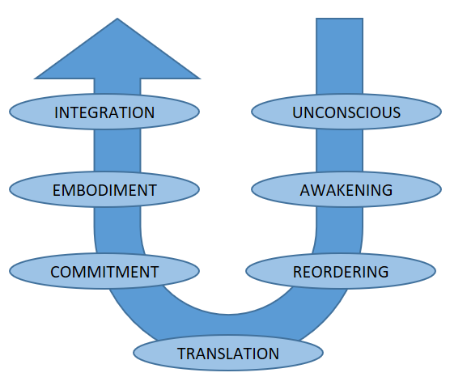

(162-164) 2. Degrees of Change
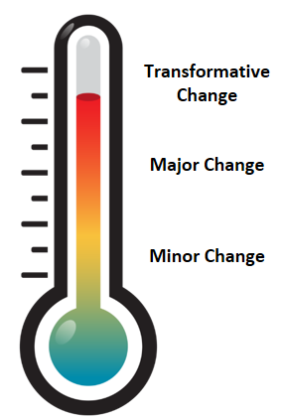
"A leader is anyone willing to help, anyone who sees something that needs to change and takes the first steps to influence that situation. . . Everywhere in the world, no matter the economic or social circumstances, people step forward to try and make a small difference. . And this is why we need to step forward for what we care about." - Margaret Wheatley, American founder, Berkana Institute
3. Dimensions of Change:
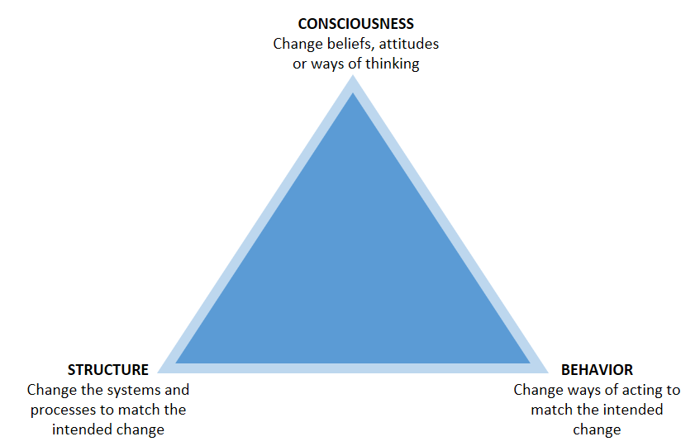
(167-175) LEAD CHANGE AND EMPOWER SUCCESS BY JAN MCDONOUGH
WHY CHANGE? CHANGE IS GOOD
1. Investigate
2. Evaluate: “I am convinced that life is 10 percent what happens to me and 90 percent how I react to it."-Charles Swindoll, American minister
3. Educate
4. Identify the impact
5. Lead by example: «True originality consists not in a new manner but in a new vision." Edith Wharton, American author
LEADING CHANGE REQUIRES VISION AND FAITH
(179-186) LEADERSHIP IS IN THE PALM OF YOUR HAND BY CAROLE SACINO
Leadership Is Like a Palm Tree: "Limitations live only in the minds, but if we use our imagination, our possibilities become limitless." -Jamie Paolinetti, American professional cyclist
PALM PRINCIPLES # 1
- Proactively demonstrate how your company can leverage your talents to achieve bottom line results
- Address challenges and overcome obstacles
- Leverage your drive, knowledge and relationships to achieve measurable results
- Maximize opportunities to learn and grow professionally and be successful
"The difference between possible and impossible lies in the person's determination" -Tommy Lasorda, America Major League Baseball player and manager
"Awareness precedes action." -Ellie Drake, American businesswoman
PALM PRINCIPLES #2
- Persevere with passion, purpose and possibilities
- Aspire to authenticity and openness when you inform, involve and engage the business, strategy and people
- Lead by example and keep moving forward with courage, conviction and commitment
- Mentor, motivate and create memorable moments that matter
"When nothing is sure - everything is possible." Margaret Drabble, English novelist
PALM PRINCIPLES #3
- Pay attention in the present moment in order to change course and shift direction as needed
- Act after understanding because you do not know what you do not know until you know it, and only then can you take action
- Listen, learn and lead with empathy, understanding and respect for others at all times
- Motivate and engage with a sense of humor
(188) How can you use the PALM Principles to meet massive change head on and succeed?
- Practice paying attention and staying in the present moment in order to change course and shift direction as needed. Do not let your attention wander!
- Learn and study the situation and your alternatives before you act because you do not know what you do not know until you know it and only then, you can take action
- Become a good listener, learn all you can about your business and leading people, so you can lead with empathy, understanding and respect for others at all times
- Remember to motivate and engage people with a sense of humor
- Never take yourself too seriously!
Reach Out and Take Leadership
(191-197) BECOMING AN INTERNATIONAL LEADER BY LINDSAY SHIELDS
"In the time of your life, live- so that in that wondrous time you shall not add to the misery and sorrow of the world, but shall smile to the infinite delight and mystery of it? -William Saroyan, American author
- Broaden Your Exposure to the world of Differences
- Network in the International Community
- Learn to Lead by Stepping Aside
(199) "Never doubt that a small group of committed people can change the world. Indeed, it is the only thing that ever has." -Margaret Mead, American cultural anthropologist
(203-205) EVERYDAY LEADERSHIP LEAD WHEREVER YOU ARE BY CHRISTINA DYER
- Self-Mastery
- Know thyself
- Transform thyself
- Master thyself
(207-210) RESPECT THE CONTEXT OF YOUR LIFE: "It is never too late to be what you might have been." -George Eliot, British novelist
SUSTAINED MOTIVATION THROUGH PURPOSE AND MEANING: Being defeated is only a temporary condition. Giving up is what makes it permanent." -Marilyn Vos Savant, American writer and columnist
COURAGE AND COMMITMENT: "Keep your fears to yourself, but share your courage with others." -Robert Louis Stevenson, Scottish writer and poet
DEVELOP AN ATTITUDE OF SERVICE AND GENEROSITY: "Rather than seeing the world as divided among different civilizations or classes, our collective future rests upon our embracing a vision of a single world in which we are all connected." -Jacqueline Novogratz, American author, founder of Acumen Fund
(212)
"I am only one,
But still I am one.
I cannot do everything, But still I can do something;
And because I cannot do everything
I will not refuse to do the something that I can do.?
- Helen Keller, American author, political activist and lecturer

